**Video 2**

Complete the missing code from the first video.

Modified file:

* kernel.cpp
* loader.s
* kernel.cpp

Create constructor for start_ctors and end_ctors. After that, create a function that call this constructor.

Changes:

* loader.s

Create a call action to the function in kernel.cpp

Changes:

Video 3:

I used this command (sudo apt install VirtualBox) in konsole to install Virtual Machine on Linux (Ubuntu).

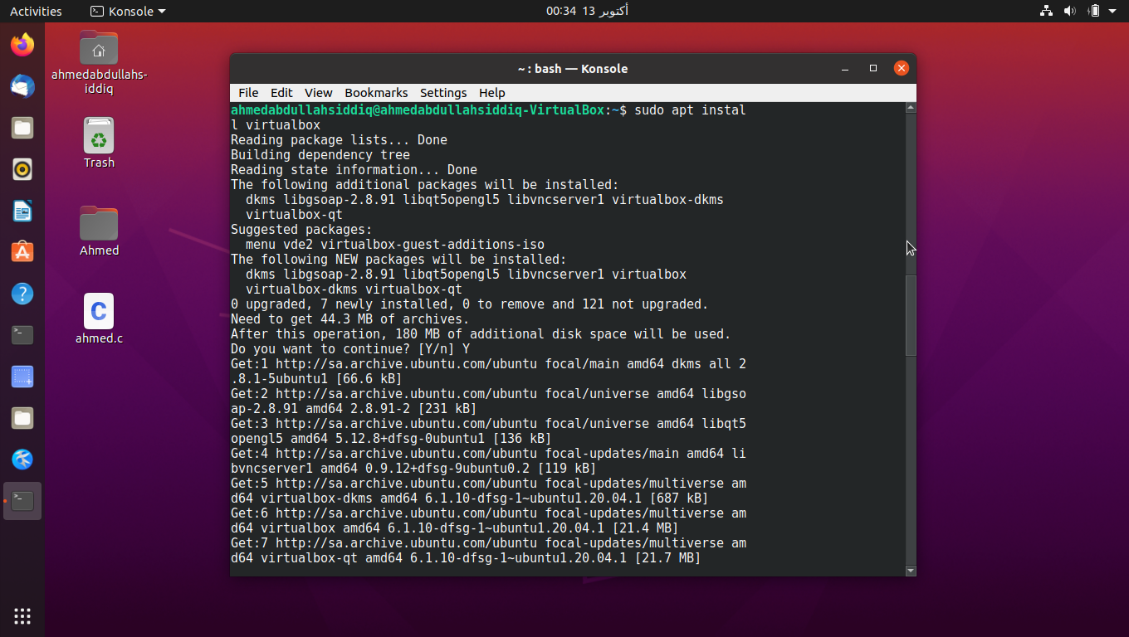

Then I wrote this command (sudo apt-get install grub-pc) to install packages on Ubuntu.

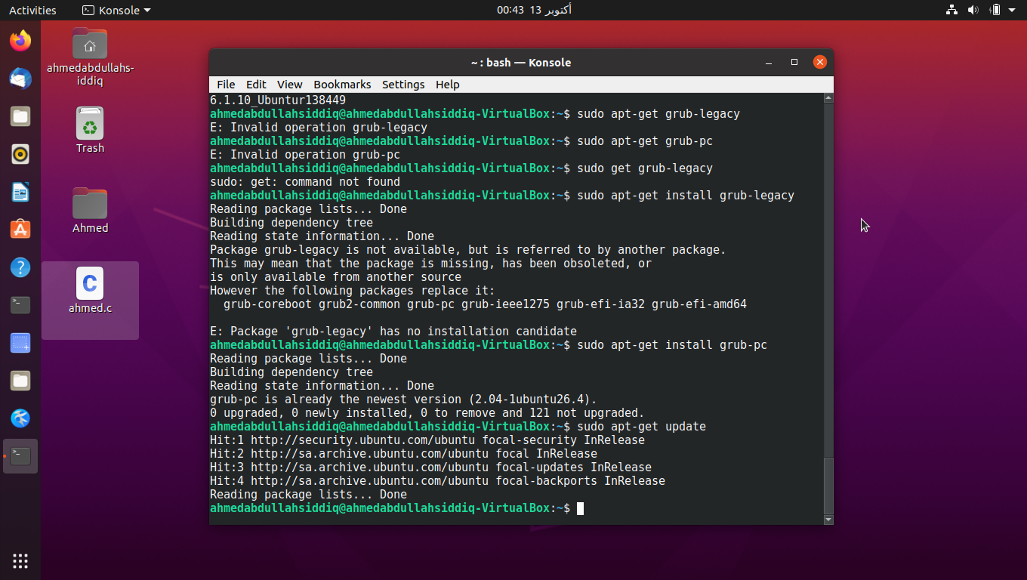

To install xorriso I used this command (Sudo apt-get install -y xorriso).

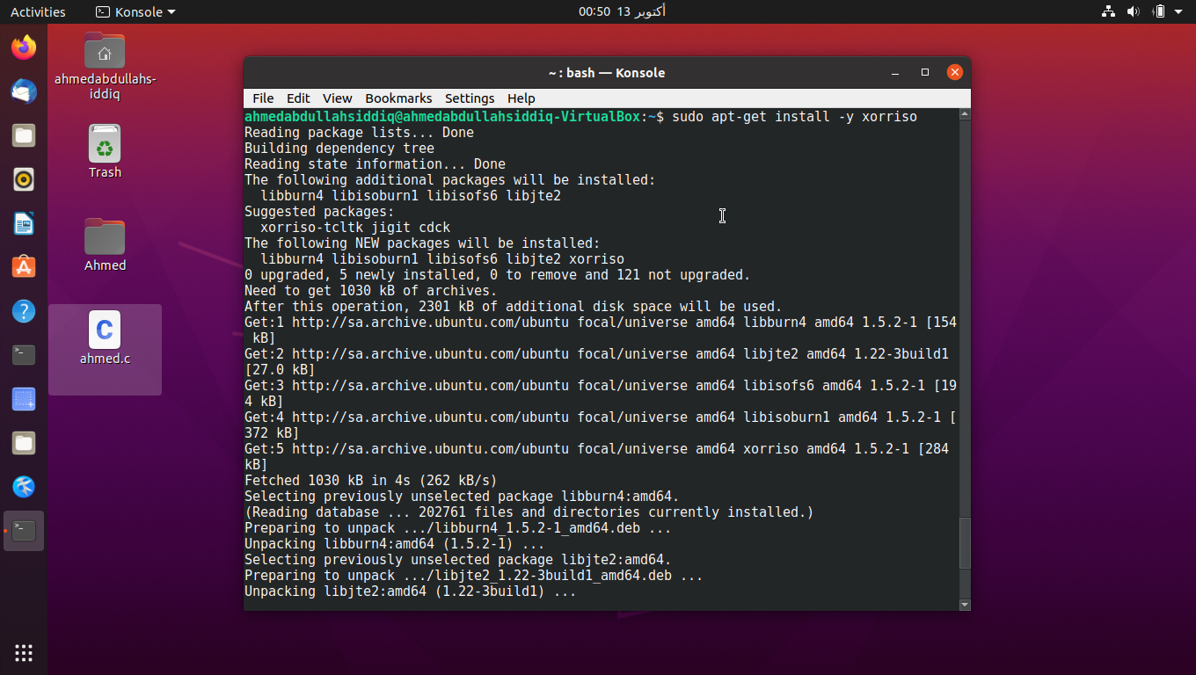

.

Then I wrote commands in (makefile) to create (iso) folder inside (myos) folder by write this command (make mykernel.iso)

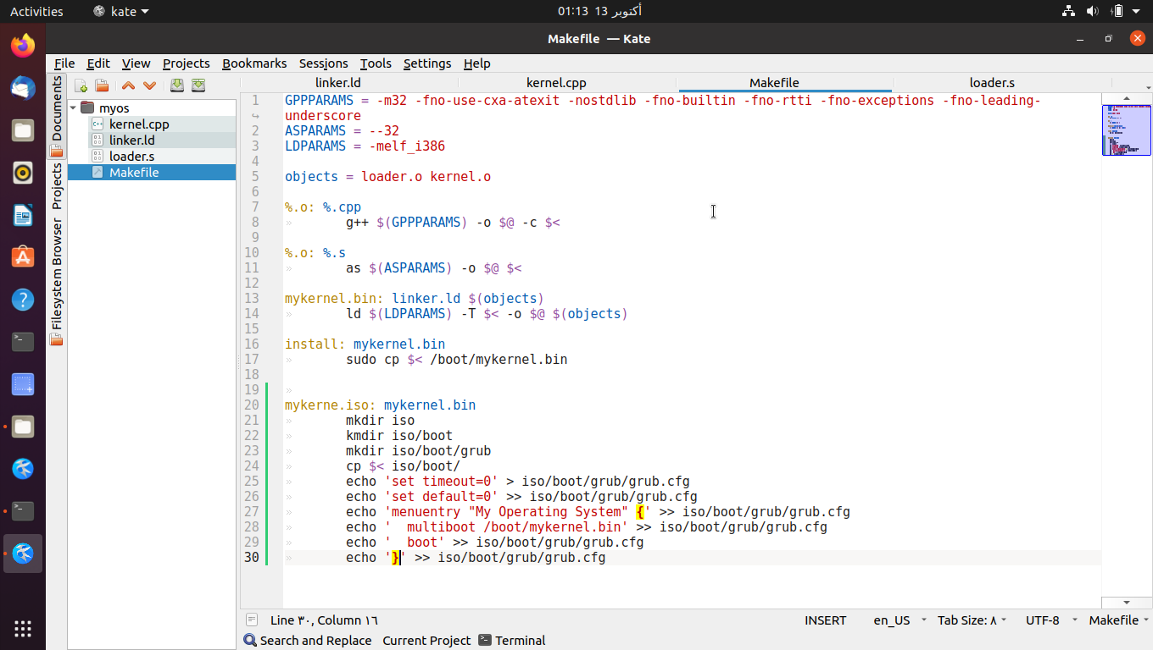

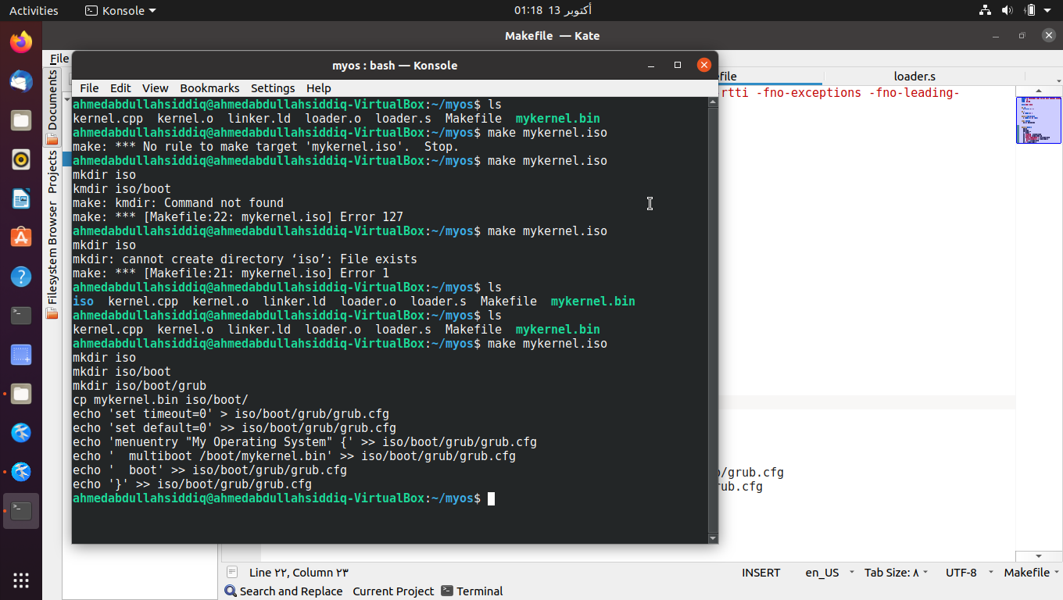

After implementation of (makefile) we created iso folder in myos folder.

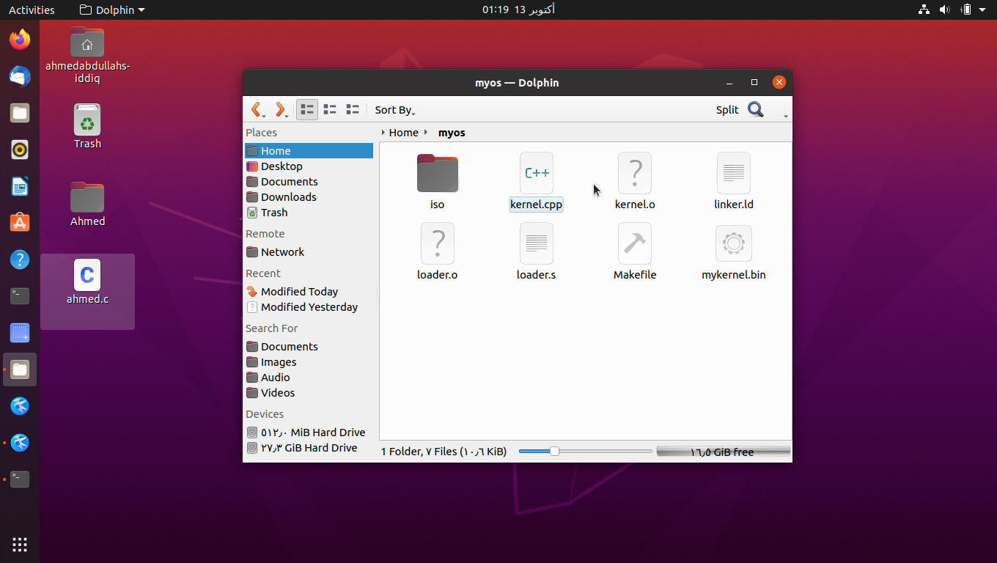

Then I wrote command in (makefile) to generate a CD copy of our OS.

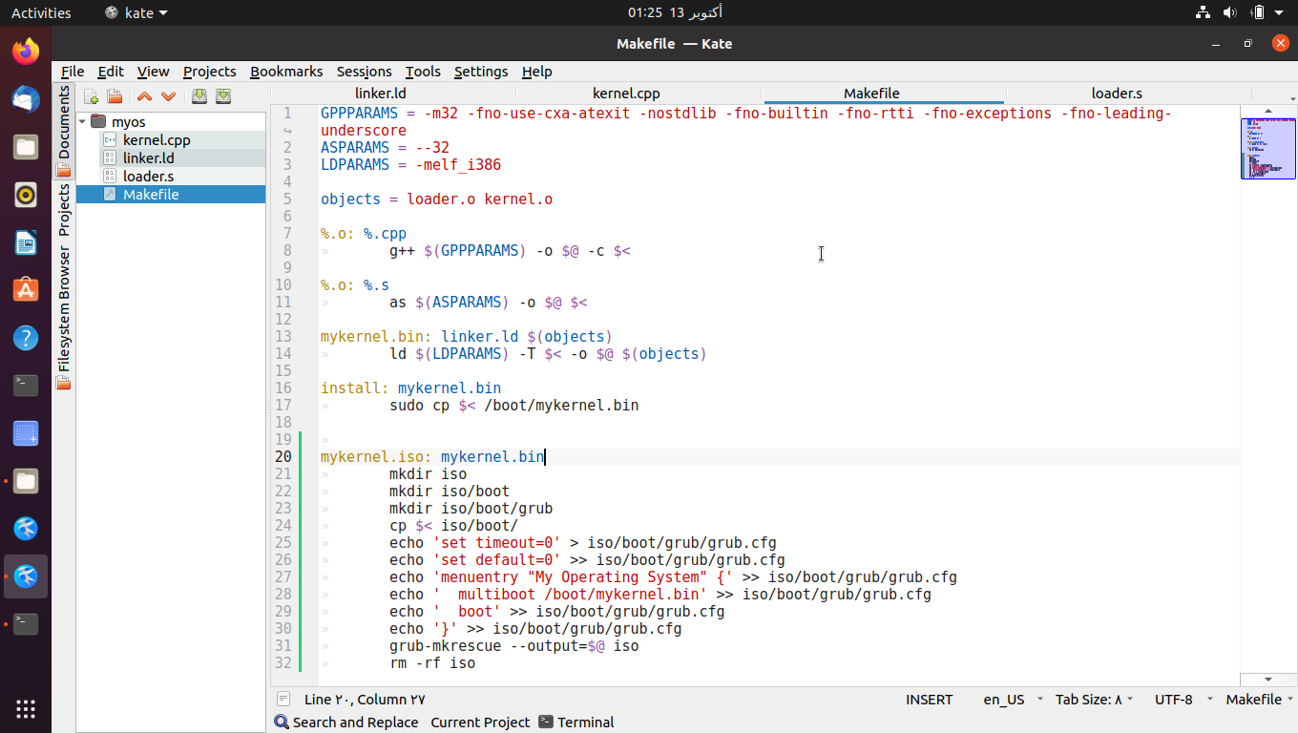

Here is the CD copy.

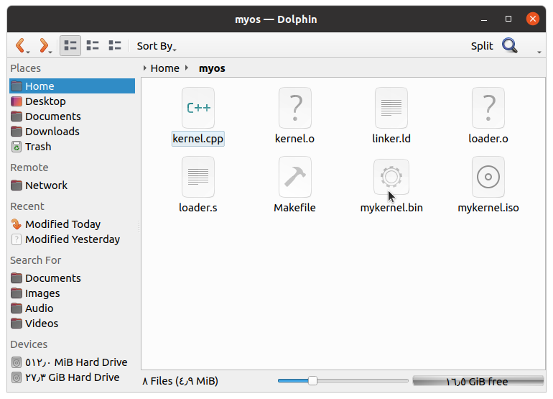

Now we will install our OS on the VM.

